LAB 4
TASK 1
1. Area Chart
o Create an area chart showing the average petal length for each species.
o Title: "Average Petal Length by Species"
o X-axis: Species
o Y-axis: Average Petal Length (cm)
o Add legend and gridlines (major and minor).
o Set the legend position to the bottom-right corner.
o Add a legend title "Species" and set the legend font size to 12.

INPUT
import matplotlib.pyplot as plt

avg_petal_length_data = data.groupby("Species")['SepalLengthCm'].mean()

plt.figure(figsize=(10, 12))
avg_petal_length_data.plot(kind='area', alpha=0.5, color='lightgreen')
plt.title("Averagae petal length by species", fontsize=14)
plt.xlabel("Species")
plt.ylabel("Average Petal Length(cm)")
plt.legend()

plt.grid(True, linestyle='--', alpha=0.6)
plt.savefig("Image1.png")
plt.show()
plt.plot()

OUTPUT
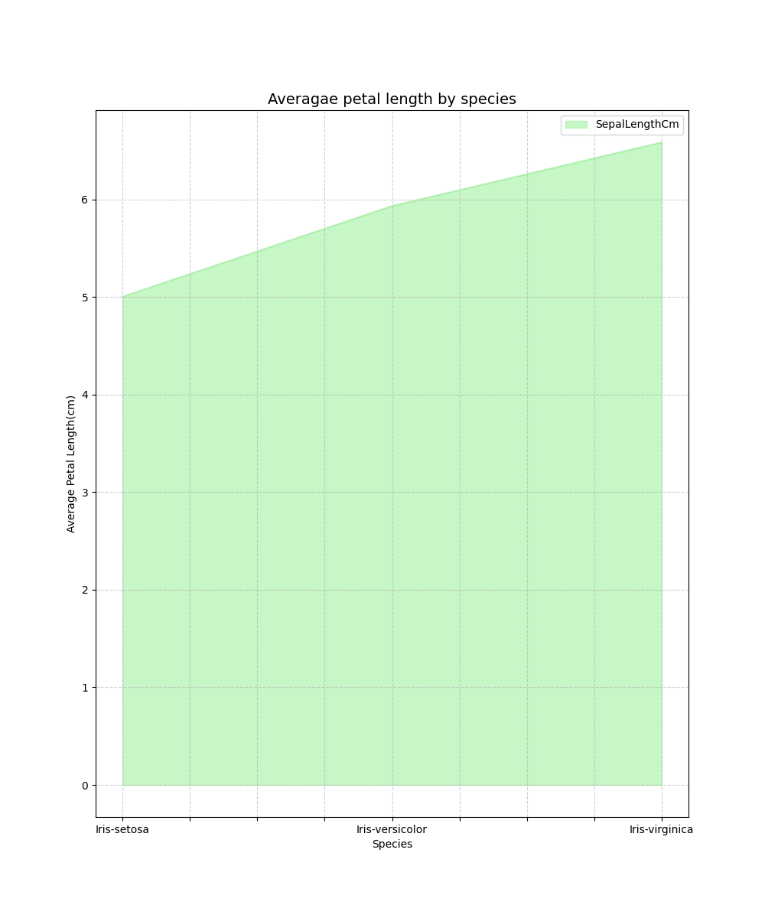
TASK 2
2. Bubble Chart
o X-axis: Sepal Length
o Y-axis: Sepal Width
o Bubble size: Petal Length
o Bubble color: Species
o Title: "Iris Flower Features"

INPUT
import matplotlib.pyplot as plt

x = data['SepalLengthCm']
y = data['SepalWidthCm']
sizes = data['PetalLengthCm'] * 30 # scale bubble size for visibility
colors = data['Species'].astype('category').cat.codes # map species to numeric codes

plt.figure(figsize=(8, 6))
scatter = plt.scatter( x, y, s=sizes, c=colors, cmap='viridis', alpha=0.6, edgecolors='w', linewidth=0.5)
plt.title("Iris Flower Features", fontsize=14)
plt.xlabel("Sepal Length (cm)")
plt.ylabel("Sepal Width (cm)")

# Add legend for species
legend_labels = data['Species'].unique()
plt.legend(*scatter.legend_elements() , title="Species")

plt.grid(True, linestyle='--', alpha=0.6)
plt.savefig("Image2.png")
plt.show()
OUTPUT
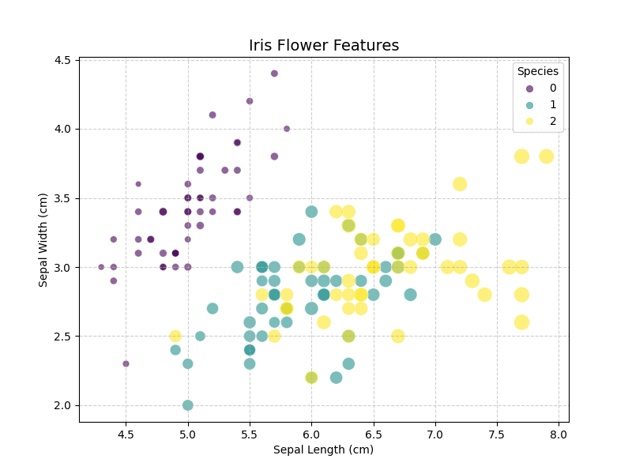
TASK 3
3. Heat Map
o Create a correlation heatmap for all numeric features.
o Title: "Heatmap of Iris features"

INPUT
import seaborn as sns

new_data = data.drop("Species", axis=1)
corr_data = new_data.corr()

sns.heatmap(corr_data, cmap='binary', annot=True)
plt.title("Heatmap of Iris Features")
plt.savefig("Image3.png")
plt.show()

OUTPUT
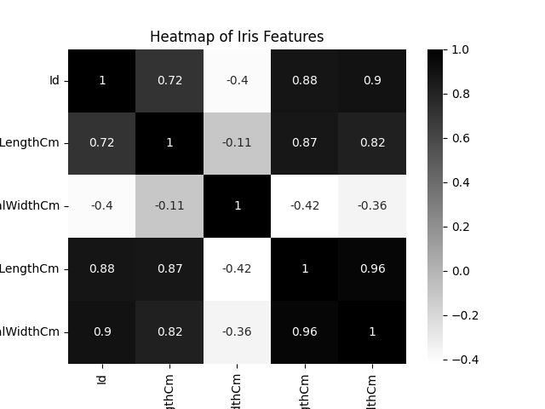
TASK 4
4. Box Plot
o Create box plots for petal length by species.
o Title: "Petal Length Distribution by Species"
o Create box plots showing the distribution of petal length for each species.
o Clearly represent the median, first quartile (Q1), third quartile (Q3), and the interquartile
range (IQR).
o Display outliers using distinct marker symbols for easy identification.
o Use different colors for each species to ensure clear visual distinction.
INPUT
# Box plot of petal length by species
sns.boxplot(data=data,x="Species", y="PetalLengthCm", palette="Set2", notch=True)
plt.title("Petal Length Distribution by Species")
plt.xlabel("Species")
plt.ylabel("Petal Length")
plt.savefig("Image4.png")
plt.show()
OUTPUT
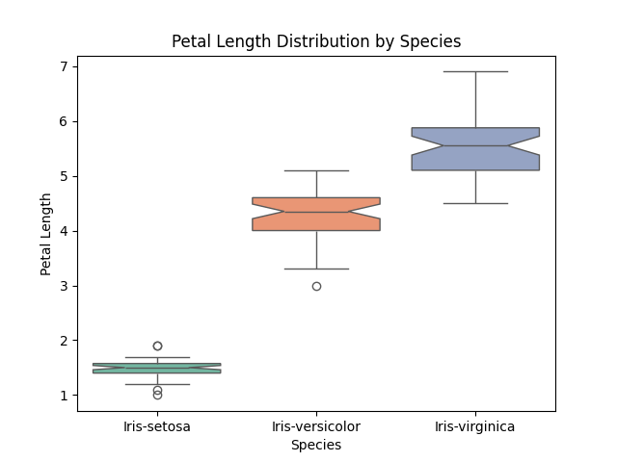
TASK 5
5. Violin Plot
o Create violin plots for petal width across species.
o Title: "Petal Width Distribution by Species"

INPUT
sns.violinplot(data=data,x="Species",y="PetalWidthCm",palette="Set3", inner="quartile")

plt.title("Petal Width Distribution by Species")
plt.xlabel("Species")
plt.ylabel("Petal Width")
plt.savefig("Image5.png")
plt.show()
OUTPUT
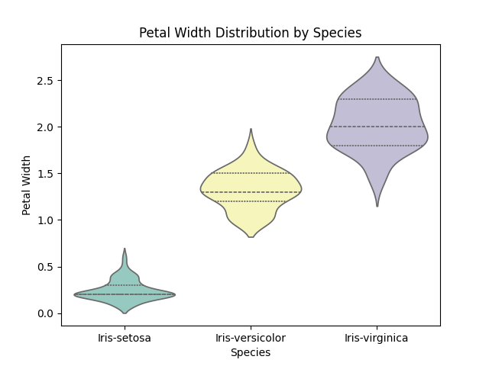
TASK 6
6. Pair Plot
o Create pairwise scatter plots between all numeric features.
o Create pairwise scatter plots between all numeric features of the Iris dataset: Sepal
Length, Sepal Width, Petal Length and Petal Width.
o Display feature-to-feature relationships across all possible combinations.
o Use a consistent axis scale for all subplots to ensure fair visual comparison. Apply
uniform marker style and size for visual consistency.
o Use different colors for different species to enable class-wise visual separation.
o Maintain color consistency for each species across all subplots.

INPUT
sns.pairplot(data=data,vars=["SepalLengthCm", "SepalWidthCm", "PetalLengthCm", "PetalWidthCm"],hue="Species",diag_kind="kde", markers="o", plot_kws={"s": 40, "alpha": 0.7} )
plt.suptitle("Pairwise Relationships in Iris Dataset", y=1.02)
plt.savefig("Image6.png")
plt.show()
OUTPUT
